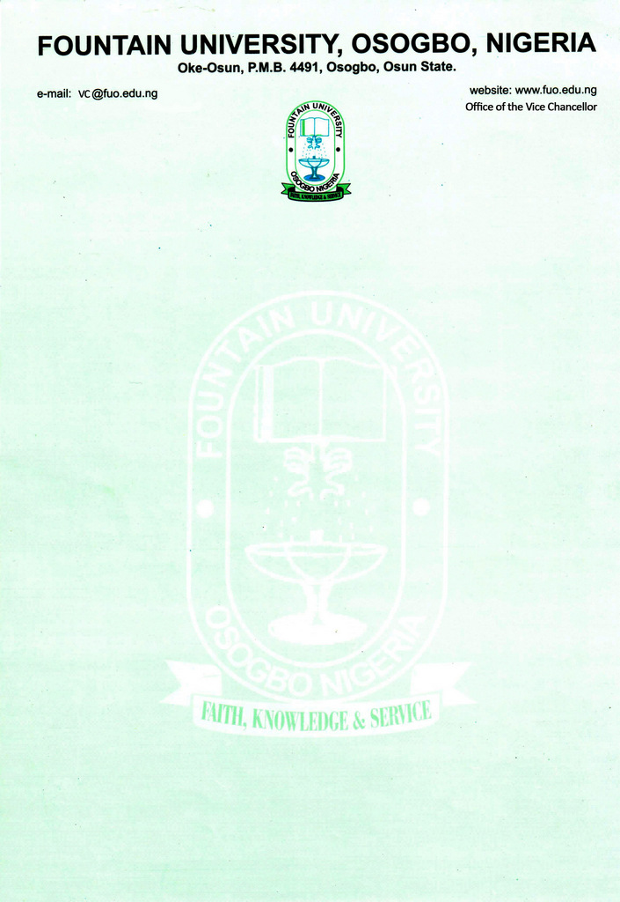

CURRICULUM VITAE
FOR FOUNTAIN UNIVERSITY 2020
Please paste @ right hand corner, a presentable passport photograph
            - Name: BADMUS, Issa Abdulwaheed
            - Present Position: Assistant Lecturer
            - College/Department: College of Management and Social Sciences/General Studies Unit
            - Place and Date of Birth: Osogbo. 12/11/1979
            - Nationality: Nigerian
            - State of Origin/Local Govt Area: Osun State/ Osogbo Local Government.
            - Marital Status: Married
            - Number and Ages of Children: Four: (a) Mufeedah (11 years) (b) AbdulMalik (9 years)
(c) Mazeedah (6 years) (d) Mukhtar (3 years)
            - Residential Address: Block 1 Flat 2, Bola Ajibola Staff Quarters, Fountain University, Osogbo, Osun State.
            - Address for Correspondence: P.M.B. 4491, General Studies Unit, College of Management and Social
Sciences, Fountain University, Osogbo, Oke-Osun Osogbo, Osun State.
            - Telephone No(s): +2348030789545
            - Institutional e-Mail: badmus.issa@fuo.edu.ng/ badmus.issaabdulwaheed@gmail.com
            - Address: P.M.B. 4491, General Studies Unit, College of Management and Social
Sciences, Fountain University, Osogbo, Oke-Osun Osogbo, Osun State.
            - Educational Institutions attended with dates (Starting with the Latest Date/Institution)
- University of Ilorin. Ilorin. 2018 -
- University of Ilorin. Ilorin. 2012 – 2014
- National Teachers’ Institute, Kaduna 2010 - 2011
- University of Ilorin. Ilorin. 2003 - 2006
- Ahmadu Bello University, Zaria. 1999 – 2001
- Muhydeen College of Arabic and Islamic Studies, Kulende, Ilorin, Kwara State. 1991-1999
- Salvation Army Primary School, Isale-Aro Street, Osogbo, Osun State. 1985 – 1990
            - Academic Qualifications obtained with dates (Starting with the Latest: Date/Qualification/Subject)
- Ph.D (Arabic Literature) In View
- M.A. (Arabic Language) 2014
- Post Graduate Diploma in Education 2010
- B.A. (Arabic Language) 2^{nd`} Class Upper Division 2006
- Advanced Diploma (Arabic & Islamic Education). 2001
- WASSCE November/December 2007
- Senior Islamic Secondary School Certificate 1999
- Primary School Leaving Certificate 1991
- National Youth Service Corps (NYSC) 2008
            - Professional Qualification(s) with dates (Starting with the Latest)
- Certificate in Word Processing/Desktop Publishing Packages 2009
            - Training/Professional courses attended with dates (Date/Qualification)
- Advanced Course on Contemporary Islamic Thought and Epistemological Integration. (International Institute of Islamic Thought) December, 2018

            - Membership of Professional bodies/societies (Date/Professional Body/Status/Type of Membership e.g. Full/Fellow/Associate/Coordinate etc)
- Member, National Association of Teachers for Arabic and Islamic Studies. (N.A.T.A.I.S) Osun State Chapter. 2006 –
- Member, Academic Society for Arabic Language and Literature in Nigeria (ASALLIN) 2018 –
            - Work Experience with dates
              - Work experience in the University
                - Administrative Officer 1, Fountain University, Osogbo, Osun State. 2015 – 2017
                - Student Affairs Officer, Fountain University, Osogbo, Osun State. 2016 - 2017
                - Assistant Lecturer, General Studies Unit, Fountain University, Osogbo, Osun State. 2017–
Courses taught at the University Level (Arabic Studies and Islamic Rituals & Ethics)
- Fountain University Arabic (FUA 101)
- Fountain University Arabic (FUA 102)
- Beginners Arabic (GNS 106)
- Arabic Conversation (GNS 201)
- Islamic Culture and Ethics (GNS 203)
- Fountain University Fiqh (FUC 101)
- Fountain University Fiqh (FUC 102)
i. Undergraduate Programmes
b. Work experience in other organization (s) (Date/Institution/Status/Responsibility)
- Muhydeen College of Arabic and Islamic Studies, Kulende, Ilorin, Kwara State. 1999–2000
(Subject Teacher)
- As-Salam International Travels Agency. (Umrah & Hajj Agent) 2006–2008
- Mariamoh Ajiri Memorial International Schools, Katsina. Subject Teacher, Head of Department (Arabic Language) and Examination Officer. 2008–2012
- Details of Administrative and Leadership Experience in the University system (Starting with dates)
a. Administrative experience (Deanship, HoD etc)
                - 1st September, 2018 - 31st August, 2019, Coordinator, General Studies Unit.
                - 1st October, 2018 - 30th September, 2019, Coordinator, National Board of Arabic and Islamic Studies
(NBAIS) in Fountain University.
                - 1st September, 2019 - 31st August, 2020, Coordinator, General Studies Unit.
                - 1st October, 2020 – 30th September, 2021, Coordinator, General Studies Unit and NBAIS Programme.

b. Other appointments in the University:
- University Missionary, Fountain University, Osogbo. 2015 -
- Conducting Salat (Prayers). 2015 -
- Conducting weekly Sunday NASFAT Asalatu in the school. 2015 -
- Coordinating and teaching of Fiqh Class Courses every Tuesday. 2015 -
- Conducting examination and results computation of all Fiqh courses. 2015 -
- Participating in rotational Jum’ah Sermon. 2015 -
- Coordinating Community Service. 2015-2017
- Counseling of the students. 2015-2017
- Hall Master at Sulaiman Adegunwa Hall of Residence 2019 – 2020
- Hall Master at Sulaiman Adegunwa Hall of Residence 2020 - 2021
- Resources (Human/Material) attracted to the University.
- Local/Community Service (e.g. Religious/Social or Political)
- 2005-2006. Vice President, Osogbo National Students’ Union. University of Ilorin Chapter.
- 2007- 2013. Assistant Branch Missioner, NASFAT Missionary Board, Katsina, Katsina State.
- 2014- till date. Assistant General Secretary, NASFAT Missionary Board, Osun Zone.
- 2014-till date. Member, NASFAT Missionary Board, Osogbo Branch, Osun State.
- Coordinating Mallam to the Chief Mufasir of Osogboland, Osogbo Central Mosque, Oja Oba,
Osogbo. 2014 till date.
- 2016-2018. Member, Admission Committee.
- 2016-2018. Member, Students Disciplinary Committee.
- 2015- till date. Member, Mosque Management Committee.
- 2017/2018 Session. Member, Convocation, Ceremony Committee.
- 2018/2019 Academic session. Member, Fountain University Senate.
- 2018- 2019. Member, Fountain University NBAIS Diploma Program.
  - National/International Assignments (including external examinership, NUC Accreditation, Assessment for academic posts, Review of academic works for journals and academic publishers etc)
                - Chief Moderator, National Board of Arabic and Islamic Studies (NBAIS) S.I.S.C.E. Examination 16th October, 2018 – Till date.
                - NYSC Programme with Mariamoh Ajiri Memorial International Schools, Kwado, Katsina, Katsina State. Subject Teacher. 2007-2008
                - Research Assistant for International Institute of Islamic Thoughts 2020.
- Thesis/Dissertation/ (Indicate for which Degree/Discipline/Year/Institution Start with the highest Degree Date/Title/Degree/Institution)
    - Panegyrics on the Prophet in ‘Isa Alabi Abubakr’s poem. (M.A. Thesis) Arabic Literature, 2014, University of Ilorin.
    - The Explanatory Book in Arabic Language. (Unpublished Textbook for Junior Secondary Schools, Book 1) 2012.
    - The Contribution of Adult Education and Development of Education in Katsina Metropolis. (Post Graduate Diploma in Education Research) National Teachers Institute, Kaduna. 2010.
    - Critical Analysis of selected Poems of As-Shaykh Jum’ah Sunusi. (B.A. Research) Arabic Literature, University of Ilorin, 2006.
    - Comparative Study of Jareer and Farazdaq Poems in Umayyad Period. (Advanced Diploma in Arabic and Islamic Education) Ahmadu Bello University, Zaria, Kaduna State. 2001.
- Listing of Academic Publications
- Books, Monograph or Patent NIL
- Chapter(s) in Book(s) NIL
- Journal Articles
    - Badmus, I. A. (2016), Umayyad Arabic Literature and its influence on Nigerian Arabic Literature: A practical study of Elegiac works of ‘Umran bin Hattan and Isa Alabi Abubakar. Al-Hikmah Jouk rnal of the Humanities, Faculty of Humanities and Social Sciences, Al-hikmah University, Ilorin, Volume 2 no 1, p. 178-195
    - Badmus, I. A. (2018), Nigerian Arabic Social Poetry: A case study of ‘Uthman Abdul Salam Muhammad’s poem. Al-Qalam Journal for Language, Literature and Linguistic Studies. Department of Languages, Faculty of Humanities, Yusuf Maitama Sule University, Kano, Kano State, Volume III, p. 165-185
    - Khalilullah, M.U and Badmus, I. A. (2019), The Phenomenon of selected Arabic Ode in the Riyadh Collection of Isa Alabi Abubakr: An Empirical Study. ظاهرة الموسيقى المختارة في ديوان الرّياض لعيسى ألبي أبي بكر:دراسة تطبيقية. Mallam Journal of Arabic Studies, Usman Dan Fodio University, Sokoto, Volume 2, p, 226-244.
    - Badmus I. A (2020) Emergence of Arabic New Loan Words among Yoruba Speakers in Southwestern Nigeria: A Critical Analysis, Fountain Journal of Management and Social Sciences. ISSN 2315-6325: 2020; Vol. 9 No. 1. Issue 7, Page 829-842. Published by Faculty of Social and Management Sciences, Fountain University, Osogbo. Available online at http://www.fountainjournals.com/index.php/fujmas/article/view/2
Articles accepted for publication: NIL
- Encyclopedia entries NIL
- Refereed Conference Proceedings NIL
- Review Articles/Book Reviews NIL
- Special e.g. Grant/fellowship, Web Presence, Award Winning Play/film, Landmark Judgement (Case)
NIL
- Research Interest (State Specific areas of investigation e.g. Gerontology as a specific area of interest in the subfield of Demography in Sociology. NIL
- Research in progress
i. List as many research projects as are in progress but provide details of only 3 stating, among others:
a. introduction
b. aims/objectives
c. methodology
d. expected result
e. contribution to knowledge/society
ii. Details for each project should be between 150 and 300 words.
- Research Collaboration Experience (Date/Institution/Project) NIL
Conferences/Workshops attended and papers presented with dates
- International Conference on the Biography of Prophet Muhammad “Impact of the Exemplary leadership style of Prophet Muhammad on Inter-Ethnic and Inter-Religious Harmony” organized by Nusret Educational and Cultural Comp. Ltd. Held on 11th December, 2019 at University of Ibadan.
- Nusret National Seminar for Academicians on “Child Upbringing” The seminar was held on Sunday 24th to Wednesday 27th November, 2018 at Nile University of Nigeria, Abuja.
- 14th National Conference on Arabic Culture in Nigeria and Prospects of Development, organized by The Academic Society for Arabic Language and Literature in Nigeria (ASALLIN) held on 5th-8th November 2018 at Bauchi State University, Gadau. I presented paper on “Yoruba-Arabic Language and Cultural Development: Emergence of new loan words Among Yoruba Speakers in Southwestern Nigeria” at the conference.
- The 4th International Conference on Islamic Universities of International Institute of Islamic Thought (IIIT) held on 7th – 9th October, 2017; at Fountain University, Osogbo.
- Directorate of Academic Planning, Office of the Vice-Chancellor Fountain University, Osogbo. One-day workshop on “The use of Technology to enhance teaching quality”. 6th December, 2017.
- Extra-Curricular activities: Reading, Traveling and Listening to news.
- Referees:
i- Dr. Mikail A Folorunsho Senior Lecturer, School of Languages, Osun State University, Ikire Campus, Osun State. Phone: 08033841249
ii- Dr. Lateef I. Onireti Associate Professor, Department of Arabic, Faculty of Art, University of Ilorin. Phone Number 08065962826
iii- Dr. Isiaq Lawal
Senior Lecturer, School of Languages, Department of Arabic Language, Osun State College of Education, Ilesha, Osun State. Phone: 08033846653
Signature: Date: 01/07/2020.

