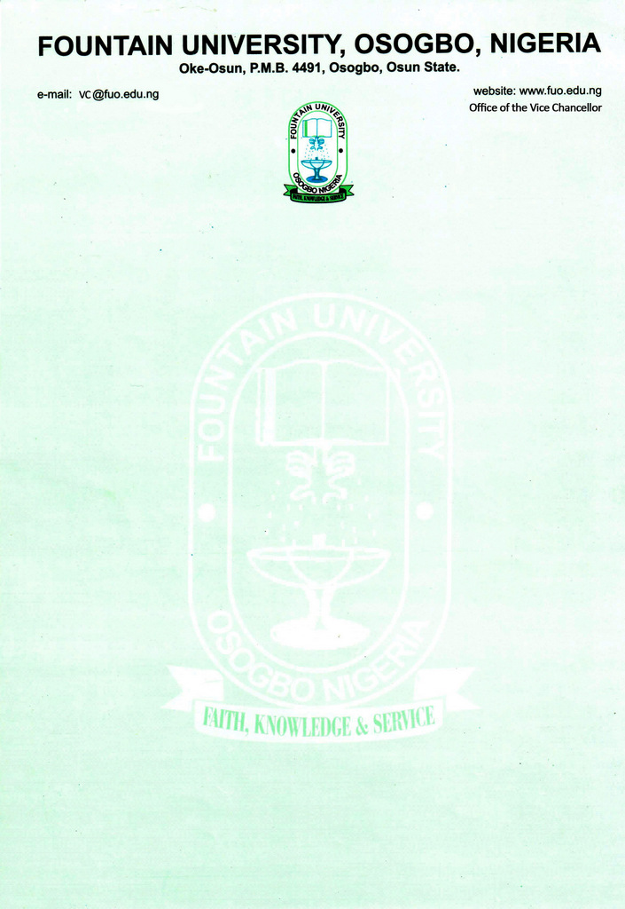

CURRICULUM VITAE
            - Name: Kolawole, Ridwan Abiola
            - College/Department: Mass Communication
            - Place and Date of Birth: 06/05/1982
            - Nationality: Nigerian
            - State of Origin/Local Govt Area: Osun/Ayedaade
            - Marital Status: Married
            - Number and Ages of Children: Three (3)
            - Residential Address: 12, Atobatele Road, Off Gbongan Road, Ataoja Estate, Osogbo.
            - Address for Correspondence: c/o Dawud Adewobi, P. O. Box 29, Gbongan, Osun State.
Telephone No(s): +2348024203808 Mobile(s): +2348134939950
Institutional e-Mail Address: ridwan.kolawole@gmail.com
            - Educational Institutions attended with dates (Starting with the Latest Date/Institution)

- University of Ibadan 2018 till date
- University of Ibadan 2014-2016
- University of Ibadan 2008-2012
- The Polytechnic, Ibadan 2004-2006

            - Academic Qualifications obtained with dates (Starting with the Latest: Date/Qualification/Subject)
- Ph.D., Communication and Language Arts, University of Ibadan (in view) 2018-
- M. A., Communication and Language Arts, University of Ibadan 2016
- B. A., Communication and Language Arts, University of Ibadan 2012
- N. D., Mass communication, The Polytechnic, Ibadan 2006

            - Professional Qualification(s) with dates (Starting with the Latest)
- Africa Check, detecting and debunking health misinformation training 2020
- Certificate in Online Journalism (UNESCO and the University of Ibadan) 2012
- Certificate in Peace Journalism (Justice, Development and Peace Commission and University of Ibadan) 2010

            - Training/Professional courses attended with dates (Date/Qualification)
- December 14 2021 Inception Workshop on Young women and men’s aspiration and resilience: Prospects for livelihoods, employment and accountability before, during and beyond COVID-19
- August 4-6, 2021 Partnership for African Social and Governance Research (PASGR): Inception Workshops, Young People Aspirations and Resilience
- June 4-5, 2021 University of Edinburgh and University of Ghana, Catalyst Regional Early Career Workshop: West Africa,
- April 13-15, 2021 Next Generation (Next Gen) of Social Sciences, African Fellowship Programme, Writing and Dissemination Workshop for Next Gen Fellows sponsored by the Social Science Research Council, New York, USA.
- December 9-12, 2019 Next Generation Social Sciences in Africa Fellows Workshop, University of Dar es Salaam, Tanzania, sponsored by the Social Science Research Council, New York, USA.
- June 26-28, 2019: Next Generation Social Sciences in Africa Fellows Workshop, Peduase Valley and Resort, Ankama Close, Aburi, Ghana, sponsored by the Social Science Research Council, New York, USA.
- January 8-22, 2020 Pan-African Doctoral Academy (PADA): Managing the Ph.D Process Centre for Wetlands, University of Ghana, Legon, Ghana
- Africa Check, detecting and debunking health misinformation training 2020
- Training in Online Journalism (UNESCO and the University of Ibadan) 2012
- Peace Journalism Training (and University of Ibadan and Justice, Development Peace Commission) 2010

            - Membership of Professional bodies/societies (Date/Professional Body/Status/Type of Membership e.g. Full/Fellow/Associate/Coordinate etc)
- Associate Member, Society for Peace Studies and Practice (SPSP)
- Member, Rural Sociological Association of Nigeria (RuSAN)
            - Work Experience with dates
              - Work experience in the University
Lecturer II, Department of Mass Communication, Fountain University, Osogbo 2021
Courses taught
i. Undergraduate Programmes
- Writing for the Mass Media
- Mass Media and Society
- Editorial writing
- Word Processing
  - Postgraduate Programmes

b. Work experience in other organisation(s) (Date/Institution/Status/Responsibility)

    - University of Ibadan, Ibadan Distance Learning Course facilitator 2021
Courses taught: Reading for Academic Purposes

    - Ecole Professionnelle Specialisee La Cite Universite, Cite Vie Nouvelle, Cotonou
Republic of Benin
Positions held: Lecturer II 2016-2019
Courses taught
  - News writing and Reporting
  - Investigative and interpretative Journalism
  - Foundation of Broadcasting
  - Specialised Reporting
  - Foreign Correspondence
  - Sociology of Mass Communication

- Pachio Resources Management Limited, 58, Adebisi Omotola Street,
Isolo, Lagos 2016
Position held: Research and Communication Officer (Contract)
Business Communications Research, Media Relations

- Osun State Broadcasting Corporation (OSBC), Km 4, Ibokun Road, Oke Baale Osogbo
Position held: Freelance Outstation News Correspondent 2010-2018

- Details of Administrative and Leadership Experience in the University system (Starting with dates)
a. Administrative experience
i. 2016-2017 Programme Coordinator, Department of Mass Communication Ecole Professionnelle Specialisee La Cite Universite, Republic of Benin 2016-2017
- Secretary, Academic Committee, Ecole Specialisee La Cite Universite, Republic of Benin 2019

b. Other appointments in the University
i. Project Supervision

- Academic Publications

- Journal Articles
- Kolawole, R. A. (2021). Labeling-Driven Identity Construction in Nigerian media Framing of Farmer-Herder Conflict. Journal of Comparative Sociology 20(5). Doi: 0000-0002-8689-4126; https://brill.com/view/journals/coso/20/5/article-p633_5.xml
- Ojebuyi, B. R.; Mobolaji, A. O. and Kolawole, R. A. Active News Audience in Covid-19 Pandemic Season: Online News Sharing Motives and Secondary Gatekeeping Decisions by Social Media Users in Nigeria. Journal of African Media Studies (accepted).
- Kolawole, R. A. and Ojebuyi, B. R. 2019. “Nigerian Journalists’ awareness of, and adherence to, social responsibility and pro-development principles.” Ibadan Journal of Humanistic Studies, 20(1) https://www.ajol.info/index.php/ibjhs/article/view/200158
- Oyedele, O. J.; Lasisi, M. I and Kolawole, R. A. (2018) Analysis of Foreign Aid-Induced Investigative Journalism Practice in Nigeria. Journal of Management and Sciences. Vol. 7(2) Pp 435-454 http://www.fountainjournals.com/index.php/fujmas/article/view/214
- Kolawole, R. A., Lasisi M. I. and Adeleke, A. O. (2017). “Sustainability of Marketing Food Crops through the Internet in Lagos, Nigeria” Journal of Agricultural Extension Society of Nigeria. Volume 21 (1), pp 204-217 http://dx.doi.org/10.4314/jae.v21i1.17
• Ojebuyi, B. R. And Kolawole, R. A. (2016) “Marginalizing the Majority: Nigerian Newspapers’ Coverage of the Rural Sections in a Profit-Driven Economy” Journal of Communication and Media Research Volume 8, Number 1, Pp 35-51, https://www.jcmrjournal.org/article?id=342

• Refereed Conference Proceedings

i. Kolawole, R. A. Kolawole, R. A (2017). “Media too should Be Held Accountable: Citizens’ Perception of Social Responsibility of selected Beninese Media” In Ekanola, A. B., Odebunmi, S. A. and Ojebuyi, B. R. (eds) Conference Proceedings, University of Ibadan, Faculty of Arts Third International Biennial Conference. Ibadan: Faculty of Arts, University of Ibadan. Pp 448-471

- ii. Kolawole, R. A. and Okiki, A. T. (2019). “Victims of Unchecked Assaults”: Intercultural Communication and Farmers’ Narrative of Herders’ Invasion in Oke-Ogun Area of Oyo State, Nigeria. The 28th National Congress of the Rural Sociological Association of Nigeria, October 7-11, 2019, at Obafemi Awolowo University, Ile-Ife, Nigeria

- Grant/fellowship
i. Research Assistantship, Nigerian Young Women and Men’s Aspiration and Resilience (Research and Uptake Project) 2021-2023
Partnership for African Social and Governance Research (PASGR), Kenya
Funder: Mastercard Foundation

ii.Doctoral Dissertation Research Fellowship, Next Generation Social Science Africa Programme, Social Science Research Council, New York 2020-2021
Funder: Carnegie Corporation of New York

                - Doctoral Dissertation Proposal Development Fellowship, Next Generation Social Science Africa Programme of the Social Science Research Council, New York 2019-2020
Funder: Carnegie Corporation of New York
                - Research Assistant, Community-based Crime Prevention and Control of Evidence and Lessons from Latin America (ELLA) 2015-2016

- Research Interests
Journalism; Media and Conflict Studies; Development Communication

- Research in progress
                - Mediatized conflict: A case of Nigerian media reportage of farmer-herder conflict
Introduction
The role of the media in conflict situation has been acknowledged by researchers either in its escalation or de-escalation (Biazoto, 2011; Akpan, Erin & Olofu-Adeoye, 2013) even though the media are saddled with the socially responsible role of enhancing peacebuilding in a conflict situation, evidences have shown that the media are sometimes accomplices in the conflict escalation (Apuke & Omar, 2020; Biazoto, 2011). With growing population amidst ethnic diversity, Nigerian media, in the recent, past have not created value for their audience who are diverse in their ethnicity, culture, religion and class (Nwachukwu et al., 2021). This assertion manifests in the picture painted by the media of different groups in Nigeria. Such labelling as immigrant, settler, native, non-native, foreigner, stranger element, host community, indigene, non-indigene among others which the media have deployed to characterize some groups who Nwachukwu, Ajaero, Ugwuoke and Odikpo (2021:57) describe as “other” do not necessarily depict such groups are the bane of conflict de-escalation in country.
Objectives
- To find out the extent to which Nigerian media are implicated in their reportage of farmer-herder conflict in the country.
- To assess the audience perception of media narratives of Nigeria’s farmer-herder conflict
Methodology
Mixed methodology: Quantitative (Content analysis and survey)
Expected result: To show the evaluation of the media in through the eyes of their audiences
Contribution to knowledge: The research aims to contribute to the field of media and conflict studies showing the relationship between the mass media and the society.
Conferences/Workshops attended
- June 7-9, 2021 International Graduate Conference, Faculty of Arts, University
of Ibadan, Nigeria
Paper presented: Taking Humanities by the Jugular: Digital Restrictions, Muting Opposing Voices in African Countries
- April 6-9, 2021 62nd International Studies Association Convention (ISA)
Paper presented: Media framing or name-calling? Conflicting identities in local farmer-herder conflicts in Nigeria

- November 6-8, 2019 13th SPSP International Conference and General Assembly
Paper presented (jointly with Babatunde Raphael Ojebuyi): Media Framing and Stakeholders’ Narrative of Farmer-Herder Conflict in North-Central Nigeria
- October 7-11, 2019 28th National Congress of the Rural Sociological Association of Nigeria
Paper jointly presented with Okiki A. T.: “Victims of Unchecked Assaults”: Intercultural Communication and Farmers’ Narrative of Herders’ Invasion in Oke-Ogun Area of Oyo State, Nigeria.
- April 8, 2018 Ghana 2018: Relationship Between Journalism and Foreign Aid: A Symposium organized by University of Leeds and University of Ghana held at the University of Ghana, Accra (February 8, 2018)
Paper presented: Foreign Aid as Predictor of Investigative Journalism Practice in Nigeria: Gains and Consequences
- El Salvador 2016: Evidence and Lessons from Latin America (ELLA): Crime Prevention Study Tour held in San Salvador, El Salvador, Central America, October 16 to October 23 2016
- Nigeria 2017: Third Biennial International Conference, Faculty of Arts, University of Ibadan, Nigeria with the theme Polity Debacle and the Burden of Being in Africa (March 14 to 18, 2017)
Paper Presented: Media Too Should be held Accountable: Beninese Perception of the Media Social Responsibility
- Agricultural Extension Society of Nigeria (AESON): 21st Annual Conference on Repositioning Agricultural Extension for Sustainable Agricultural Development and National Economic Regeneration held at the University of Ibadan, Nigeria (April 17-20, 2016).
Paper (jointly presented with Lasisi, Mutiu Iyanda): “Sustainability of Communicating Food Crops through the new media in Lagos, Nigeria”
Workshops
August 4-6, 2021 Partnership for African Social and Governance Research (PASGR): Investigators and Research Assistants’ Inception Workshops, Young People Aspirations and Resilience
June 4-5, 2021 University of Edinburgh and University of Ghana, Catalyst Regional Early Career Workshop: West Africa,
April 13-15, 2021 Next Generation (Next Gen) of Social Sciences, African Fellowship Programme, Writing and Dissemination Workshop for Next Gen Fellows sponsored by the Social Science Research Council, New York, USA.
January 8-22, 2020 Pan-African Doctoral Academy (PADA): Managing the Ph.D Process Centre for Wetlands, University of Ghana, Legon, Ghana

December 9-12, 2019 Next Generation Social Sciences in Africa Fellows Workshop, University of Dar es Salaam, Tanzania, sponsored by the Social Science Research Council, New York, USA.

June 26-28, 2019: Next Generation Social Sciences in Africa Fellows Workshop, Peduase Valley and Resort, Ankama Close, Aburi, Ghana, sponsored by the Social Science Research Council, New York, USA.
- Extra-Curricular activities
Recreational footballing; exploring opportunities
- Referees
Professor Tayo Lamidi (Mentor)
Department of English
University of Ibadan, Ibadan, Nigeria
tayolamidi@yahoo.com
08033637962

Dr Babatunde R. Ojebuyi (teacher, thesis supervisor, mentor, collaborator)
Senior Lecturer
Department of Communication and Language Arts
University of Ibadan, Ibadan, Nigeria
ojebabson@gmail.com
+2348032804101

Dr Oludayo Tade (mentor, collaborator)
Senior Lecturer
Department of Sociology
University of Ibadan, Ibadan, Nigeria
dotad2003@yahoo.com
08033515003

