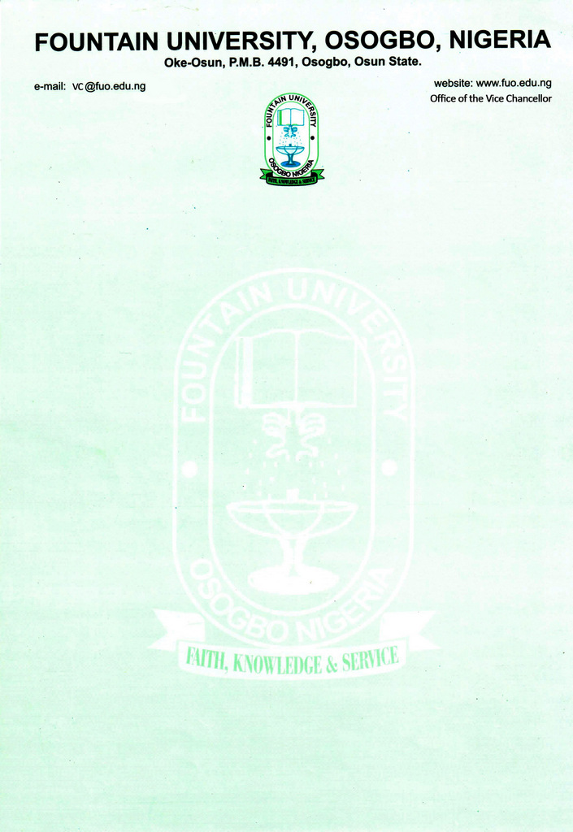

CURRICULUM VITAE
FOR FOUNTAIN UNIVERSITY 2021
- Full Name: ABIOLA, Adekunle Saheed
- Present Position: Lecturer II
- College/Department: Law/Private and Business Law
- Place/ Date of Birth: Ilorin/ 7th May, 1989
- Nationality: Nigerian
- State Of Origin/ Local Government Area: Osun/Ifelodun
- Marital Status: Married
- Number and Ages of Children: 2, (4) and (2)
- Residential Address: 25, Arugbo Street, Osin Okete, Off Ajase Ipo Road, Ilorin, Kwara State, Nigeria
- Address for Correspondence: 25, Arugbo Street, Osin Okete, Off Ajase Ipo Road, Ilorin, Kwara State, Nigeria
- Telephone No(s): 07033957612; 08086557050
- Institutional e-Mail Address: lawsaheed@gmail.com
- Educational Institutions Attended with Dates
Institution Date
- Obafemi Awolowo University, Ile-Ife, 2018-2020
- Nigeria Law School, Lagos, 2015-2016.
- Kogi State University, Anyigba, 2010-2015.
- Kwara State College of Education, Oro, (IJMBE) 2007-2008
- Government Unity Technical College, Amodu Asogbolu, Kwara State 2007-2008

- Academic Qualifications obtained with Dates
Institution Qualification Date
- Obafemi Awolowo University, Ile-Ife, LL.M (Master of Laws) 2021
- Nigeria Law School, Lagos, B.L (Barrister at Law) 2016
- Kogi State University, Anyigba, LL.B (Bachelor of Law) 2015
- Kwara State College of Education, Oro (IJMBE) 2008
- Government Unity Technical College, NECO 2008
Amodu Asogbolu, Kwara State
- Chartered Institute of Arbitration ADR Certificate 2020
- Mediator Academy Certificate in Commercial Mediation 2021
- Excellent Touch Academy, Certificate in Data Processing 2015
Ilorin, Kwara State
- Professional Membership with Dates

- Member, Nigerian Bar Association, Ilorin, Kwara State
- Member, Nigerian Bar Association, Nigeria
- Member, Muslim Lawyers Association of Nigeria, Ilorin, Kwara State.
- Member, Muslim Lawyers Association of Nigeria, Nigeria.
16. Work Experience with Dates
- Lecturer II, Department of Private and Business, Fountain University, Osogbo, Osun State (November 2021 till date)
- Counsel/Administrative Counsel, Khaf Chambers, 93 Muritala Muhammed Way, Ilorin, Kwara State (March 2018 till October 2021)
- Legal Officer, Lankotheory Education Services Ltd, Ilorin, Kwara State (November 2017 to February 2018)
- NYSC Legal Officer, Kings University Ode Omu, Osun State 2016 - 2017
- Law School Extern-Yusuf Olaolu Ali & Co, Ilorin, Kwara State (June 2016 - July 2016)
- Teacher, Cornerstone Comprehensive High School, Ilorin, Kwara State (2012 to 2017)
- Teacher, Lankotheory Education Services Ltd (2013 to 2021)
17. Courses Taught at the University Level
- Nigerian Legal Method
- Nigerian Constitutional Law
- Nigerian Labour Law
18. Administrative Experience
- Level Adviser, 200L Students, Fountain University, Osogbo, 2021/2022 Academic Session.

- Member, Task Force on Council of Legal Education Accreditation November 2021.

- Member, NBA, Ilorin Bar Dinner Committee (2021)

- Secretary, Development Law Resources Organization (2018 - 2021).

- Administrative Counsel, Khaf Chambers, 93, Muritala Muhammed way, Ilorin, Kwara State (2019 till date).

- Member, Ad-Hoc Committee to investigate stolen items from the University Premises, Kings University, Ode-Omu, Osun State (2017).

- Head of Sensitization, NYSC ICPC CDS GROUP, Odeomu Osun State (2017).

- Publicity Secretary, Muslim Students Society of Nigeria, Nigeria Law School, Victory Island, Lagos State (2016).

- Legal Clinic Group Coordinator, Faculty of Law, Kogi State University, Anyigba (Coordinating visits to courts, Prisons and Police Station) (2014).

- Assistant Secretary, Law Students Society Caretaker Committee, Kogi State University, Anyigba (2013).

- Member, National Executive Screening Committee (Surah Committee) of National Association of Muslim Law Students held at University of Abuja, Gwagwalada Abuja (2013).

- General Secretary, National Association of Osun State Students, Kogi State University Chapter, Anyigba, Kogi State (2012).

- Chairman, Constitution Drafting Committee, National Association of Osun State Students, Kogi State University Chapter, Anyigba, Kogi State (2012)
19. Projects/Thesis/Dissertation
- The Principle of Quality and Sanctity of Life in the Euthanasia Debate: An Islamic Law Perspective (Thesis Submitted for the award of Bachelor of Laws) (LL.B) (2014)

- The Application of Arbitration in Merger and Acquisitions Agreement: An Examination of the Problems of Consent in Parallel Proceedings (Thesis Submitted for the award of Master of Laws) (LL.M) (2020)
20. Journal Articles
- Abiola Adekunle Saheed (2021) ‘Effective Management of Nigerian Borders to contain Banditries in Nigeria,’ Al-Hikmah University Journal of Private and Business Law, 1 (1) 17-31

Publisher: Department of Private and Business Law, Al-Hikmah University, Nigeria
21. Core Personal Strengths
- Ability to work under pressure
- Excellent oral and written communication skills
- Good analytical and problem solving skills
- Good presentation skills

22. AWARDS, HONOURS, PRIZES AND FELLOWSHIPS:
- NAPSS UNILORIN Award of Recognition as Astute Legal Practitioner (2021)
- Director General, Nigerian Law School’s Award for First Class Students (2016)
- Best overall Student in Civil Litigation SNAP TEST, Nigerian Law School, Victoria Island, Lagos State (2016)
- 2nd Best overall Student in Property Law Practice Ethics SNAP TEST, Nigerian Law School, Victoria Island, Lagos State (2016)
- 3rd Best overall Student in SNAP TEST, Nigerian Law School, Victoria Island, Lagos State (2016)
23. Extra-Curricular activities
- Reasoning, Travelling and watching movies.

24. Referees

PROFESSOR TUNJI OYELADE
Department Public and International Law,
Obafemi Awolowo University,
Ile-Ife, Osun State
08037187790

ASSOC. PROF. HANAFI A. HAMMED
Department of International and Jurisprudence Law,
Kwara State University,
Malete, Kwara State
08033843685

DR. ISIAQ A. ABDULWAHEED
Founder, Lankotheory Education Services Ltd,
Lecturer, Department of Political Science,
University of Ilorin,
Ilorin, Nigeria
08038295398

Signature/Date

