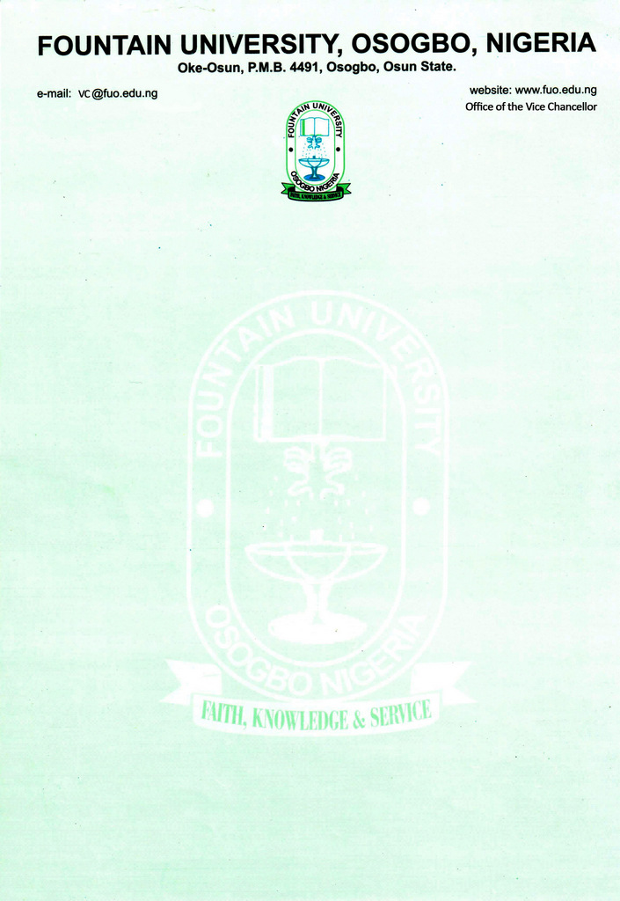

CURRICULUM VITAE
            - Name: ALAO, Idris Ibrahim
            - College/Department: Law/Islamic Law
            - Place and Date of Birth: 08/07/1987
            - Nationality: Nigerian
            - State of Origin/Local Govt Area: Oyo/Ogbomoso North
            - Marital Status: Married
            - Residential Address: 5, Green Roof House, Tanke Bubu Road, Sanrab junction, Along University Road, Ilorin, Kwara State
            - Address for correspondence: Suite 3, Atagisoro Complex, Beside Mazab Events Centre, Tipper Garage, Ilorin, Kwara State.
            - Phone Number: 07061142890
Institutional e-Mail Address: --- & idrisibnalao@gmail.com

            - Educational Institutions attended with dates
University of Ilorin, Ilorin 2019 to date
Nigerian Law School, Abuja 2016-2017
University of Ilorin, Ilorin 2011-2016
Lagos State University, Ojo 2007-2011
Daru Da‘wah Arabic College, Isolo, Lagos 2007-2009
Lagos State University, Ojo 2003-2005
State High School, Alimosho 1997 -2003

            - Academic Qualifications obtained with dates
LL.M (Unilorin) In view
LL.B (Unilorin) 2016
B.A (Ed) (LASU) 2012
Senior Arabic-Islamic Education Certificate 2009
Dip. in Arabic and Islamic Studies (LASU) 2005
Senior School Certificate Examination 2003

            - Professional Qualification(s) with dates

TRCN Certificate of Registration (Cert. Teacher) 2021
Nigerian Institute of Translators and Interpreters (Cert. Translator) 2019
Certificate of Call-to-Bar (Barrister-at-Law) 2017
            - Training/Professional courses attended with dates

- November 2021 – January 2022: Professional course in Islamic Estate Distribution, Centre for Islamic Heritage, Al-Hikmah University, Ilorin
Courses taken: Practice of Shari‘ah in Nigeria, Principles and Practice of Mirath in Nigeria, Theoretical Aspects of Mirath, Practical Aspects of Mirath, Literatures on Mirath.
- November 2021: Maiden Training/Workshop of the Institute of Translation Arts, University of Ilorin, Ilorin: Translation and Globalization
Course taken: Current Issues in Translation Research, Research Skills & Methods in Translation Studies, Development of Translation Studies, Processes in Translation, Translator Entrepreneur, Legal Translation as a Specialized Translation, Introduction to Interpreting, Translation as Literary and Creative Practice, Translation as Cultural & Inter-media Practice and Translation and Technology

- November 2020: Da‘wah Training Programme of Al Azhar International Academy for the Training of Religious Leaders, Preachers and Jurists, Cairo, Egypt
Course taken: Arabic Language, Islamic Legal Theory (Usul al Fiqh), Contemporary Fiqh Issues (al Qadaya al Fiqhiyyah al Mu‘asirah), Islamic Law of Inheritance (‘ilm al Faraidh), Issues in the Exegesis of the Glorious Qur’an (Mahawirun fit Tafseer), Science of Hadith (Uloom al Hadith), Contemporary Issues in Islamic commercial transactions (Qadaya Mu‘malat Mu‘asirah), Contemporary Issues in Islamic theology (Qadaya ‘Aqadiyya), Contemporary issues in Islamic medical rulings, Contemporary Issues in devotional acts (Qadaya Fiqhiyyah Mu‘asirah fil Ibadat), Islamic Legal Maxims (Qawa‘id Fiqhiyyah), Objectives of Islamic Law (Maqasid Shari‘ah), Da‘wah Studies (Fiqh Da‘wah), Mass communication (Fann al Ittisal bil Jamahir).

- November, 2019: 4th African International Conference on Islamic Finance: Infrastructure Financing, Sustainability and the Future of African Markets, organized by Metropolictan Skills Limited, held at Eko Hotels & Suites.

- October 2019: 17th Nigerian Institute of Translators and Interpreters (NITI) Congress and Workshop: Translation and Indigenous Languages, held in Presken Hotel, Wuse Zone 7, Abuja

- April 2017: Annual Imams Conference for Capacity-building, organized by Lekki Muslim Ummah (LEMU) held at Lekki Central Mosque Complex, Lagos.

            - Membership of Professional bodies/societies
Member, Nigerian Association of Law Teachers (NALT)
Member, Nigerian Association of Islamic Law Teachers (NAILT)
Member, Nigerian Bar Association (NBA)
Member, Nigerian Institute of Translators and Interpreters (NITI)
Member, Nigerian Association for Educational Administration and Planning (NAEAP)
Member, Association of Nigerian Authors (ANA)
Member, Commonwealth Council for Educational Administration and Management (CCEAM)
            - Work Experience with dates
              - Work experience in the University
Courses taught at the University Level
i. Undergraduate Programmes
Introduction to Islamic Law, Historical Development of Islamic Law (Tarikh Tashri‘)

- Details of Administrative and Leadership Experience in the University system (with date)
a. Administrative experience (Deanship, HoD etc)
Coordinator, Department of Islamic Law March – Sept,, 2021
Coordinator, Department of Islamic Law October, 2021– Sept., 2022

- Local/Community Service
                - Member, C’ttee on Visit by Regulatory Agencies to New Programmes July, 2021
                - Member, Taskforce on Council of Legal Education Accreditation Visit Dec., 2021

- Listing of Academic Publications
- Books, Monograph or Patent

Alao I. Idris, 2020, Maqālātun fī Ba‘dil Qadāyā ash Shari‘iyyah wal Qānūniyyah fī Nayjīriyā (A Treatise on contemporary Shari‘ah and legal issues in Nigeria), ISBN: 978-978-985-936-8.

Alao I. Idris, 2020, Bāqatul Muhamāt: ‘Ibarun wa fawāid fi Hayāti Tā’ifatin minal Muhāmīn (Parcel of the Bar: Selected lessons from the lives of a selected group of Muslim Lawyers), ISBN: 978-978-985-935-1.
- Journal Articles
Alao I. Idris, 2018, “Da‘ful Mahāratil Lughawiyyah ‘inda Shar‘iyyīn fi Nayjīriyā: Asbābun Wa hulūl” (Poor Language Skills among Shari‘ah Scholars in Nigeria: Causes and Solutions), published in Al Hikmah Journal of Islamic Law, Vol.2, June 2018, pp. 169-189
Alaro A. Abdul-razzaq & Alao I. Idris (2019), “Challenges of the Emerging Markets of Islamic Finance (IF) in Africa: Nigeria as a Case study”, published in International Review of Entrepreneurial Finance, Vol. 2, Issue 1, June 2019, pp. 17-41
- Research Interest
Law and Religion, Interactions between International Law and Islamic Law, Islamic Jurisprudence (Usūl al Fiqh), Islamic Law of Transactions (Fiqhul Mu‘āmalāt), Relevance and Effective application of Islamic Law within the context of Islamic Finance, Islamic Constitutional and Administrative Law, Comparative Constitutional Law, Islamic Legal Education and Practice.
- Conferences/Workshops attended and papers presented with dates
Imam-Tamim, M. Kamaludeen & Alao I. Idris” “Arabic: the Language of Shari‘ah, Islamic Legal Education and Practice in Nigeria”, National Conference on Sharī‘ah in the Nigerian Legal Education System, jointly organized by the Department of Islamic Law, University of Ilorin, in collaboration with the Nigerian Supreme Council for Islamic Affairs, held at the University Auditorium, between 13th - 15th November, 2018.
- Extra-Curricular activities:
Reading, Writing, Travelling and Translating

- Referees
Hon. Justice Abdurraheem Ahmad Sayi
Kadi’s Chambers,
Kwara State Sharia Court of Appeal &
Member, Advisory Committee of Experts,
Sterling Bank Plc.

Professor Abdul-Razzaq Abdul-Majeed Alaro
Faculty of Law,
University of Ilorin, Ilorin &
Member, Financial Regulation Advisory Council of Experts,
Central Bank of Nigeria

Assoc. Prof. Umar Oseni
CEO, International Islamic Liquidity Management Corporation,
Malaysia.

