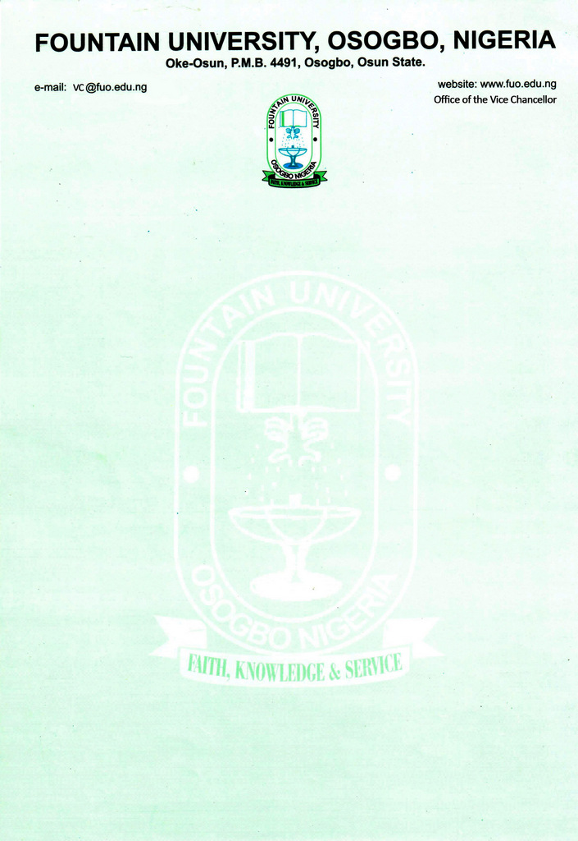

CURRICULUM VITAE
            - Name: Yakubu, Rukayat Oluwatoyin
            - College/Department: Natural and Applied Sciences/ Chemical Sciences
            - Place and Date of Birth: Lagos state, 23/08/1988
            - Nationality: Nigerian
            - State of Origin/Local Govt Area: Kwara state/Irepodun local goverment
            - Marital Status: Married
            - Number and Ages of Children: one/ 5 years
            - Residential Address: 76, Ireakari community oke-ijetu Oshogbo, Osun state
            - Address for Correspondence: Biochemistry unit, department of chemical sciences
            - Telephone No(s): +2348031961226 Mobile(s): +2348024740529
            - Institutional e-Mail Address:
            - Educational Institutions attended with dates (Starting with the Latest Date/Institution)
University of Ilorin, Ilorin, Nigeria 2014-2020
University of Ilorin, Ilorin, Nigeria 2012-2014
University of Ilorin, Ilorin, Nigeria 2007-2011
Marywood Grammar School, Ebute Metta, Lagos 1998-2004
Orire Private School, Orile Iganmu, Lagos State 1992-1998

            - Academic Qualifications obtained with dates (Starting with the Latest: Date/Qualification/Subject)
Doctor of Philosophy in Biochemistry 2020
Masters of Science in Biochemistry 2014
Bachelor of Science in Biochemistry 2011
Second Class Honors – Upper Division
Senior Secondary Certificate Examination 2004
First School Leaving Certificate 1998
            - Professional Qualification(s) with dates (Starting with the Latest): Nil
            - Training/Professional courses attended with dates (Date/Qualification): Nil
            - Membership of Professional bodies/societies (Date/Professional Body/Status/Type of Membership e.g. Full/Fellow/Associate/Coordinate etc): 2014 Society for Experimental Biology of Nigeria Full
            - Work Experience with dates (FUO)
              - Work experience in the University
Courses taught at the University Level (subject area of specialization)
i. Undergraduate Programmes (B. Sc. Biochemistry and Nutrition from 2020-date)
BCH - Structure and Chemistry of Biomolecules
BCH - Enzymology
BCH - Tissue Biochemistry
BCH - Nutritional Toxicology

  - Postgraduate Programmes: Nil
b. Work experience in other organisation(s) (Date/Institution/Status/Responsibility)
Industrial Training (SIWES), Nigerian National Petroleum Cooperation (NNPC MEDICALSERVICE) Victoria Island, Lagos 2010
National Youth Service Corp - Bells University of Technology, Ota, Ogun State (Laboratory Assistant) 2011-2012
Part-time lecturer Al-Hikmah University Adewole Ilorin 2020-2021
- Details of Administrative and Leadership Experience in the University system (Starting with dates)
a. Administrative experience (Deanship, HoD etc)
i. 300 level Adviser 2021-date
ii. Departmental representative on library and examination time table 2021-date

b. Other appointments in the University: Nil
- Resources (Human/Material) attracted to the University: Nil
- Local/Community Service (e.g. Religious/Social or Political): Nil
  - National/International Assignments (including external examinership, NUC Accreditation, Assessment for academic posts, Review of academic works for journals and academic publishers etc): Nil
- Thesis/Dissertation/ (Indicate for which Degree/Discipline/Year/Institution Start with the highest Degree Date/Title/Degree/Institution)
- Listing of Academic Publications
(1) Yakubu, M. T. and Jimoh, R. O. (2014). Carpolobia lutea roots restore sexual arousal and performance in paroxetine-induced sexually impaired male rats. Revista Internacional de Andrologia 12(3):90-99.
(2) Yakubu, M.T. and Jimoh, R. O. (2014). Aqueous extract of Carpolobia lutea root ameliorates paroxetine-induced anti-androgenic activity in male rats. Middle East Fertility Society Journal 20: 192-197.
(3) Yakubu, M. T., Salimon, S. S., Abdul-Rasheed, R. O., Opakunle, M. F., Jimoh, R. O. and Nafiu, M. O. (2014). Effects of aqueous extract of Cissus populnea stem on function indices of the ovary and uterus of female Wistar rats. Centerpoint Journal (Science Edition) 20(2): 131-14.
(4) Nafiu, M.O., Abdulsalam, T.A., Jimoh, R.O. and Kazeem, M.I. (2015). Ameliorative effect of Lecaniodiscus cupanioides (Sapindaceae) aqueous root extract in loperamide-induced constipated rats. Tropical Journal of Pharmaceutical Research 14(6):1057-1062.
(5) Yakubu, M. T., Nurudeen, Q. O., Salimon, S. S., Yakubu, M. O., Jimoh, R. O., Nafiu, M. O., Akanji, M. A., Oladiji, A. T. and Williams, F. E. (2015). Antidiarrhoeal activity of Musa paradisiaca
- Research Interest (Toxicology and Reproductive Biochemistry)
- Research in progress
- Research Collaboration Experience (Date/Institution/Project)
- Conferences/Workshops attended and papers presented with dates
a. Yakubu, M.T. and Jimoh, R.O. Anabolic and androgenic activities of aqueous extract Carpolobia lutea root in paroxetine-induced sexually impaired male rats. Paper presented at the 14th annual conference of Nigerian Society for Experimental Biology (NISEB) held at Ladoke Akintola University of Technology Ogbomosho, Oyo State, Nigeria. May 5th- 8th 2014.
b. 44thAnnual Conference of Science Association of Nigeria held at University of Ilorin, Ilorin, Nigeria, April 27 – May 1st 2014 33rdAnnual Conference of the Nigerian Society of Biochemistry and Molecular Biology (NSBMB) held at University of Ilorin, Ilorin, Nigeria. November 11th – 14th 2014
25. Extra Curricular activities: Reading and Traveling
26. Referees
Prof. H. O. B. Oloyede (Mentor)
Department of Biochemistry,
University of Ilorin, Ilorin, Nigeria
Phone No. +234 8033736994
Email Address: oboloyede@yahoo.com

Dr. L. A. Usman, (Lecturer)
Department of Chemistry,
University of Ilorin, Ilorin, Nigeria
Phone No. +234 8035032378
Email Address: lamidiusman09@gmail.com

Prof. M. A. Akanji, (Mentor)
Department of Biochemistry,
University of Ilorin, Ilorin, Nigeria
Phone No. +234 8034725751
Email Address: akanjima@gmail.com

