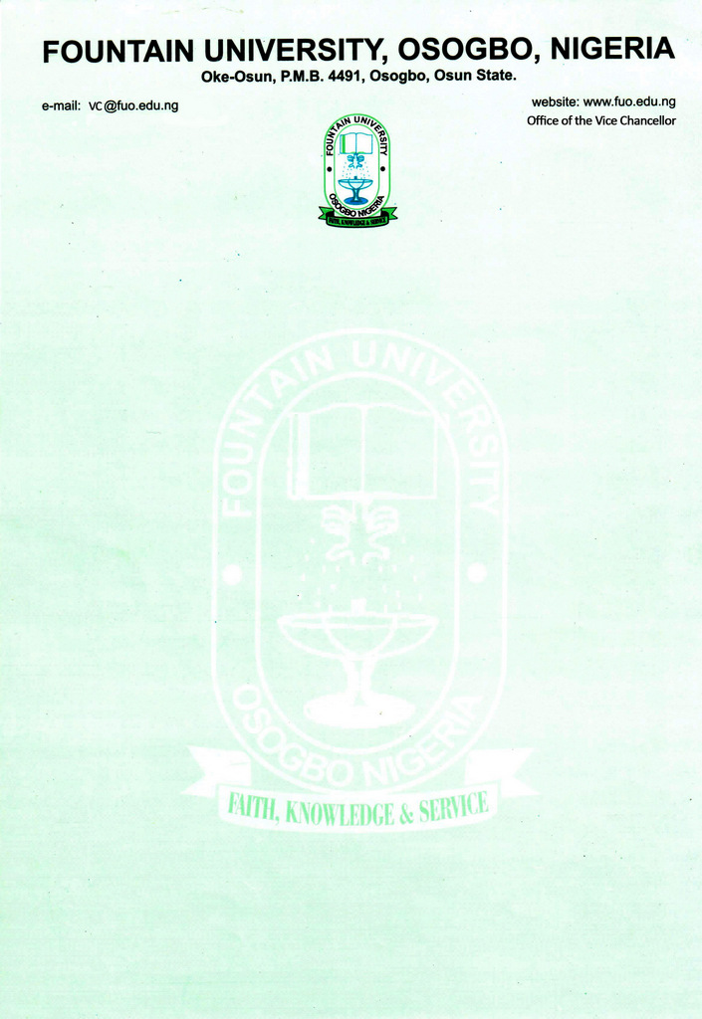

CURRICULUM VITAE
            - Name: SHITTU-ADENUGA, Zaynab Omotoyosi
            - College/Department: Law / Private and Business Law
            - Place and Date of Birth: 07/03/1990
            - Nationality: Nigerian
            - State of Origin/Local Govt Area: Oyo/ Oyo East
            - Marital Status: Married
            - Number and Ages of Children: 3/ Ages 6,5 and 2
            - Residential Address: No 7, Kumuyi Street, Ibikunle Area, Osogbo, Osun State.
            - Address for Correspondence: No 7, Kumuyi Street, Ibikunle Area, Osogbo, Osun State.
Mobile(s): 08055567161/09021870884
Institutional e-Mail Address: shittuadenuga.zaynab@fuo.edu.ng
            - Educational Institutions attended with dates (Starting with the Latest Date/Institution)
- University of Ibadan (Ibadan, Nigeria) September 2019-Date
- University of Ibadan (Ibadan, Nigeria) February 2015- November 2016
- Nigerian Law School (Bwari, Garki, Abuja) October 2012– August 2013
- University of Ibadan (Ibadan, Nigeria) October 2008–August 2012
            - Academic Qualifications obtained with dates (Starting with the Latest: Date/Qualification/Subject)
Doctor of Philosophy in Law (PhD)
- Doctor of Philosophy in Law (PhD) September 2019-Date

- Masters of Law (LLM) Ph.D. Grade ) February 2015- November 2016

- Barrister at Law (BL) Second Class Upper Division Oct. 2012– Aug. 2013
Completed modules in Property Law Practice (Grade A), Corporate Law Practice (Grade A), Criminal Litigation (Grade A), Law in Practice (Grade A) and Civil Litigation (Grade B+).

- Bachelor at Law First Class Honors (6.4 out of 7.0) Oct. 2008–Aug. 2012
Completed several modules including the Legal Methods, Family law, Criminal Law, Criminology, Islamic Law, Law of Contracts, Law of Torts, Evidence amongst others

- Professional Qualification(s) with dates (Starting with the Latest)
Council of Legal Education October 2008-August 2012
Call to Bar Certificate

13 Work Experience with dates
a. Lecturer, College of Law, Fountain University February 2021- Till Date
- Delivering lectures and tutorials
- Preparing and developing teaching aids
- Preparing examination questions and recording same
- Invigilating during examinations
b. Courses taught at the University Level (subject area of specialization)
Undergraduate Programmes: Legal Method I &II, Law of Contract I & II, Nigerian Legal System I&II

c. Work experience in other organisation(s) (Date/Institution/Status/Responsibility)
- Centre for Research, Innovation, Development and Entrepreneurship UK
Research Assistant January 2022
- Trust Chambers (Osogbo, Nigeria) September 2016-January 2021
Associate Counsel
- Conducted legal research on different areas of law
- Gave legal advice to clients on issues relating to marriage, divorce and custody of children
- Prepared incorporation Documents, sale of land agreements, leasehold or tenancy agreements, non-disclosure agreements, letter of undertakings and expression of Interest.
- Drafted pleadings and briefs
- Personally handled cases in courts

- Grace InfoTech Limited March 2016- August 2016
(Publishers of Law Pavillion electronic law report)
Legal Analyst
- Analysed and summarised court judgments for electronic publications

- University of Ibadan (Ibadan, Nigeria) February 2015-November 2016
Faculty of law (Tutorial/ Research Assistant)
- Taught First-Year Law Students “ Legal Method”

- Niyi Ajewole & Co (Ibadan, Nigeria) September 2014- January 2015
Counsel-In-chamber
- Drafted pleadings and briefs; and
- Conducted clients interview and gave legal advice to clients

- Attorneys, Arbitrators & Associates (Ibadan, Nigeria) November 2013- September 2014
Counsel-In-chamber

14 Details of Administrative and Leadership Experience in the University system (Starting with dates)
a. Administrative experience
i. Coordinator, Department of Common Law July 2021- Sept. 2021
ii. Coordinator, Department of Private and Business Law Oct. 2021- Sept 2022
b. Other appointments in the University
i. Member, FUO College Debate Panel
ii. Member, Committee on Remissness in Facilitating the switch over to new portal.
iii. Member, Committee on Visit by Regulatory Agencies to new programmes.
Iv. Team Leader, Taskforce on Council of Legal Education Accreditation
- Coordinator, Department of common Law July- September 2021
- Coordinator, Department of Private and Business Law for 2021/2022 Academic Session

- Thesis/Dissertation/ (Indicate for which Degree/Discipline/Year/Institution Start with the highest Degree Date/Title/Degree/Institution)
- LLM thesis (Grade A) titled “The Legal framework for assisted reproductive technology in Nigeria and selected jurisdictions”(2016)
University of Ibadan
Ii LL.B Thesis (Grade A) titled An Appraisal of the Islamic contract law. (2012), University of Ibadan

- Listing of Academic Publications
- Journal Articles
Zaynab O. Shittu-Adenuga, The Legal Framework for Domestic Violence On Male Victims, ABUAD Journal of Public and International Law, 2021.

Zaynab O. Shittu-Adenuga, The Impact of Covid-19 on infertility and Assisted Reproductive Technology in Nigeria, African Consortium on Law and Religion, 2022

- Awards: Best Student in Jurisprudence and Legal Theory, 2012.
University of Ibadan Post-Graduate Scholarship, 2016.

- Research Interest: Comparative Family Law including Islamic Family Law, and Sexual and Reproductive Rights.

- Extra-Curricular activities: Reading

- Referees
- Serifat Olubunmi Labo-Popoola
Department of Languages and Literary Studies
Faculty of Arts
Adeleke University, Ede.
- Ali-Balogun Silifat
Bursar, Fountain University,
Osogbo.
iii) Adediran Maruf
Senior Associate/ Head of Chamber
Trust Chambers,
Opposite Aiyegbaju International Market,
Osogbo.

