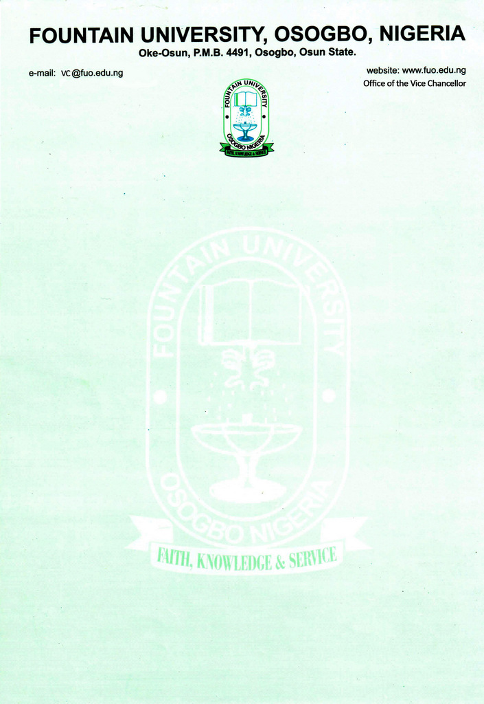

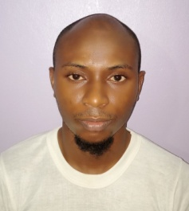
CURRICULUM VITAE
            - Name: Mustapha, Sodiq Sunkanmi
            - College/Department: College of Law, Islamic Law Department
            - Place and Date of Birth: Mokwa 05/04/1991
            - Nationality: Nigerian
            - State of Origin/Local Govt Area: Offa
            - Marital Status: Married
            - Number and Ages of Children: Two (5 years & 2 years)
            - Residential Address: Adebayo Ojuolape Street, off Iqra College, Islamic Village, Ilorin West LGA, Ilorin, Kwara State.
            - Address for Correspondence: Adebayo Ojuolape Street, off Iqra College, Islamic Village, Ilorin West LGA, Ilorin, Kwara State.
            - Telephone No(s):______________Mobile(s): +234810115109
Institutional e-Mail Address: musodiq@gmail.com
            - Educational Institutions attended with dates (Starting with the Latest Date/Institution)
University of Ilorin 2020-TILL DATE
University of Ilorin 2016 -2020
Nigerian Law School (Kano Campus) 2013-2014
Mahdul Manar Lidirasatul Arabiyah Wal Islamiyah Ilorin,
Kwara State 2010-2013
University of Ilorin, Ilorin 2008-2013
Iqra College, Ilorin 2003-2008
Iqra Basic School 1998-2003

            - Academic Qualifications obtained with dates (Starting with the Latest: Date/Qualification/Subject)
Ph.D Islamic Law In-View
LLM. Islamic Law 2020
BL. Law 2014
Thanawiyah (Senior) Certificate in Arabic and Islamic Studies 2013
LLB. Islamic & Common Law 2013
West Africa Senior School Certificate (WAEC GCE) 2007
First School Leaving Certificate 2003

            - Professional Qualification(s) with dates (Starting with the Latest)
BL. Law 2014
            - Training/Professional courses attended with dates (Date/Qualification)
Dispute Resolution Specialist (DRS) 2014
            - Membership of Professional bodies/societies (Date/Professional Body/Status/Type of Membership e.g. Full/Fellow/Associate/Coordinate etc)
Nigerian Bar Association (NBA) 2014
Nigerian Association of Law Teachers (NALTS) 2019
Nigerian Association of Islamic Law Teachers 2020
Member, National Association of Muslim Lawyers(NAMLAS) 2014
            - Work Experience with dates
              - Work experience in the University
Courses taught at the University Level (subject area of specialization)
i. Undergraduate Programmes
ISL 101: Introduction to Islamic Law
ISL 203: Islamic Legal Texts (Ayaat-Ahkaam Wal-Ahaadith at
Tashri‘iyyah
17. Work experience in other organisation(s) (Date/Institution/Status/Responsibility)

Lecturer II, Islamic Law Department, Bola Ajibola College of Law Crescent University, Abeokuta, Ogun State. 2018-2021

Part Time Lecturer ICAN Studies, Al-Hikmah University Ilorin, Ilorin, Kwara State 2016-2018

Jaiye Agoro & Co. Solicitors & Advocates Notary Public, No. 24 Idowu Taylor Street, Victoria Island, Lagos. 2014-2016
- Details of Administrative and Leadership Experience in the University system (Starting with dates)
a. Administrative experience (Deanship, HoD etc)
b. Other appointments in the University
i. Member, Task Force on Council of Legal Education Accreditation 202
- Resources (Human/Material) attracted to the University
- Local/Community Service (e.g. Religious/Social or Political)
                - Assistant Imam, Masjid Huda, Ogunbiyi Street, Islamic Village, Ilorin
                - Enumerator, World Health Organization, Ogun State
  - National/International Assignments (including external examinership, NUC Accreditation, Assessment for academic posts, Review of academic works for journals and academic publishers etc)
                - Journal Reviewer, Online Journal of Islamic Management and Finance (OJIMF, 2021)
                - Resident Monitor, 2021 Jamb Examination (Benue State)
                - Resident Monitor, 2020 Jamb Examination (Ekiti State)
                - Presiding Officer INEC 2015 General Election
- Thesis/Dissertation/ (Indicate for which Degree/Discipline/Year/Institution Start with the highest Degree Date/Title/Degree/Institution)
- Legal Liabilities of Artificial Intelligent Entities under Islamic Law, Ph.D Islamic Law (in-view), University of Ilorin, Ilorin, Kwara State.
- Juristic Analysis of the Provisions on Diyyah under the Kano State Shariah Penal Code 2000, LL.M Islamic Law, 2020, University of Ilorin, Ilorin, Kwara State.
- The rights of Unborn Child under the Common and Islamic Laws
- Listing of Academic Publications
- Books, Monograph or Patent

- Chapter(s) in Book(s)
- Journal Articles
Author(s), year, “title” Journal name, volume/issue, series, (if applicable), page range, (DOI) document object identification (if available)
- Mustapha S. Sodiq, Adeleke A. Abdulateef, Shittu D. Abdulwahab, 2021, “Diyyah under the Shariah Penal Code of Kano State; A Reflection or Deflection from Classical Maliki School of Law”, Journal of Shariah Law Research , Islamic University Of Malaya, Malaysia
- Mustapha S. Sodiq, 2020, “The Effect of Advancement in ICT on the ‎Practice of Islamic Law in Nigeria”, Crescent University Law Journal (CRULJ) Vol. 5, 17-31.
- Mustapha S. Sodiq, 2019, Congenital Anomalies as a Ground for Abortion in Nigerian" National Institute For Legislative and Democratic Studies Journal of Law Review, Vol. 2 (1)
- Mustapha S. Sodiq, 2019, Procedure for Appointment of a Qādī in Nigeria: A Hindrance to the Practice of Islamic Theocracy, Journal Of Shariah Law Research , Islamic University Of Malaya, Malaysia,Vol.4 (1), 89-104
- Encyclopaedia entries
i. ……………………
ii. ……………………
- Refereed Conference Proceedings
i. ……………………
ii. ……………………
- Review Articles/Book Reviews
i. ……………………
ii. ……………………
- Special e.g. Grant/fellowship, Web Presence, Award Winning Play/film, Landmark Judgement (Case)
i. ……………………
ii. ……………………
- Research Interest
Islamic Law
Artificial Intelligence and ICT
Islamic Law of Finance and Capital Market
- Research in progress
i. List as many research projects as are in progress but provide details of only 3 stating, among others:
a. introduction
b. aims/objectives
c. methodology
d. expected result
e. contribution to knowledge/society
ii. Details for each project should be between 150 and 300 words.
- Research Collaboration Experience (Date/Institution/Project)
- Conferences/Workshops attended and papers presented with dates
i. …………………..
ii. …………………..
- Extra Curricular activities
Football, Taekwando and Video Games.
- Referees
- three (3) referees, 2 of whom must be academic who are familiar with the academic and scholarly progression of the candidate/applicant over a reasonable length of time. (Name/Institution/Address) stating in what capacity (mentor, collaborator, teacher, degree project supervisor etc.
- Professor Egbewole Abdulwahab, Department of Jurisprudence and International Law, Faculty of Law, University of Ilorin. Phone No: 07031084046 (Mentor and Teacher)
- Professor Abdulmajeed Alaro, Department of Islamic Law, Faculty of Law, University of Ilorin. (Mentor and Teacher)
- PROFESSOR ABDUL-QADIR ZUBAIR, DEPARTMENT OF ISLAMIC LAW, AL-HIKMAH UNIVERSITY, ILORIN, KWARA STATE, PHONE NO: 08034031725 (Teacher and Supervisor)

