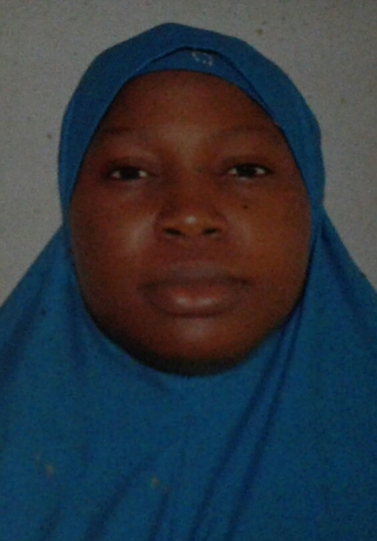
Adegbore Abidemi Kafayat
Adegbore Abidemi Kafayat was born in the city of Abeokuta. She had her Bachelor of Science Degree in Biochemistry (BSc. Biochemistry) from Federal University of Agriculture, Abeokuta (FUNAAB), after which she proceeded for her Masters Degree in Public Health, Health Promotion and Education option, at the University of Ibadan, Oyo State. She is currently an Assistant Lecturer in the Department of Public Health, College of Basic Medical and Health Sciences (COBMEHS), Fountain University, Osogbo. Outside academics, she enjoys humanitarian services and all forms of community outreaches that can help people in taking charge of their health. This passion was developed from the field experiences she gathered while volunteering with several Non-Governmental Organizations (NGO) that are keen in touching the physical, social, mental and psychological lives of community members, hence, promoting health giving behaviours through different Health Promotion and Education strategies thereby fitting into the World Health Organization (WHO) definition of health. She is always open to collaboration with other stakeholders in achieving “Health for All” and “Health Equity” regardless of our race, gender, ethnicity and religion affiliations.

ADEGBORE, Abidemi Kafayat
Abaku Estate, Ijetu AGarage Ilesha, Osogbo, Osun state.
E-mail: adegborekafayat@gmail.com
Phone contact: +234 8032818622

GENERAL INFORMATION
- Date and Place of Birth: 13th April, 1987; Abeokuta, Ogun State
- Marital status: Married
- Contact Address: Department of Public Health,
Fountain University, P.M.B 4491,
Osogbo, Nigeria
- Present Position and Salary: Assistant Lecturer (FUASS Level 2 Step 1)
- Date of Present position: 2nd March, 2020
- Specialization: Health Promotion and Education

- EDUCATIONAL BACKGROUND
- Institutions Attended with Dates
- University of Ibadan, Ibadan 2015- 2017
- University of Agriculture, Abeokuta 2005-2010

- Academic Qualifications with Dates
- MPH Health Promotion and Education 2017
- B.Sc. Biochemistry 2nd Class Upper Division 2010

- Certification
Certificate of Participation
i. Strengthening CSOs Program Delivery on Female Genital Mutilation 2019
ii. Protection and Assistance to Vulnerable Migrants and Persons 2019
- Continuous Medical Education for Health Providers on Integrated Vector Management for Malaria Control 2015
- WORK EXPERIENCE
- Assistant Lecturer, (Health Promotion and Education), Department of Public Health, Fountain University, Osogbo, Osun State. March 2020, till date.
- Program Officer, Eagles Health Development and Initiative, 2018 - 2020
- Teacher and Human Resource Personnel, Hartfords Schools, Arijo, Apete 2017-2018
- Beneficiary, (Health Officer), Federal Government N Power Volunteer Corps, 2016- 2020.
- Intern, Oyo State Agency for the Control of AIDS, 2016.
- Teacher, Allahu-Li-Ayu, Comprehensive College, Arola, Apete, 2013- 2015
- Teacher, Olayoole Kiddies College, Onikoko Apete. 2013

- Membership of Professional Bodies: Member, Society of Public Health Professionals in Nigeria (SPHPN)
- Research
    - Misuse of Insecticide Treated Nets among Household Heads in Apete Community, Ido Local Government, Oyo State
    - The potency of Lawsonia inermis and Alstonia boonei as an antimalarial in plasmodium infected mice
- Letter of Commendation and Appreciation: Given by the former Head of Department of Health Promotion and Education (Prof. O. Oladepo) on knowledge shared through mini presentation on Integrated Vector Management for Malaria Prevention and Eradication.

