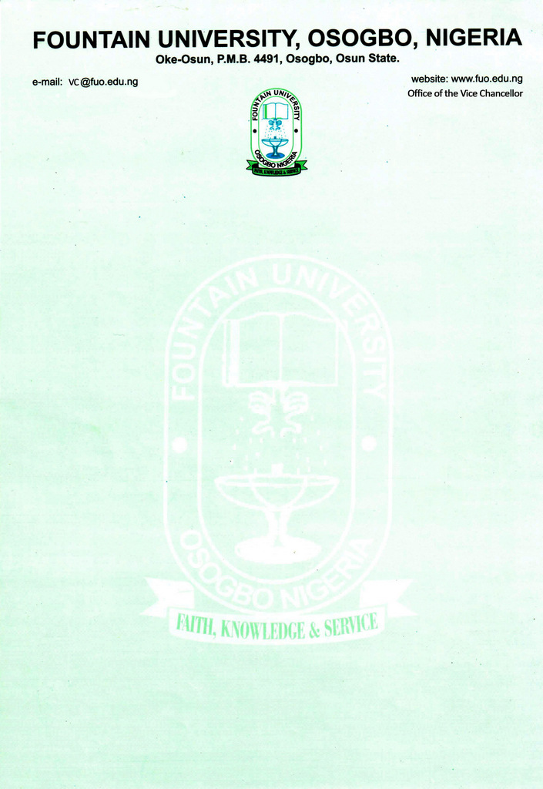

CURRICULUM VITAE
1. Name in Full: OLATUNJI, Moshood Abiodun
2. College/Department: College of Management and Social Sciences/Political Science & Public Administration
3. Place and Date of Birth: Iragbiji/28th November, 1975
4. Nationality: Nigerian
5. State of Origin/Local Government Area: Osun/Boripe
6. Marital Status: Married
7. Number and Ages of Children: Four (4) (17, 14, 12 and 6 years)
8. Residential Address: 308B, Zone 6 Abidogun Area, Ota- Efun, Osogbo, Osun State
9. Address for Correspondence: Department of Political Science & Public Administration, Fountain University, P.M.B 4491, Osogbo, Osun State. Telephone No(s): 08035204570; 07057549688
Institutional e-Mail Address: olatunji.moshood@fuo.edu.ng
10. Educational Institutions Attended With Dates
- Kwara State University, Malate 2017 - Date
- Obafemi Awolowo University, Ile- Ife, Osun State, Nigeria 2012 - 2015
- Obafemi Awolowo University, Ile- Ife, Osun State, Nigeria 1999 - 2003
- Osun State College of Education, Ila-Orangun 1994 - 1997
- West African School Certificate (O/Level) Oct./Nov. - 1998
11. Academic Qualifications
  - Ph.D Political Science (In Progress)
  - M. Sc. Political Science 2015
  - B.Sc.Ed Political Science 2003
  - Nigeria Certificate in Education 1997
  - West African School Certificate (O’ Level) 1998

12. Professional Qualifications with Dates:
- Teachers’ Registration Council of Nigeria (Certified Member) 2017

13. Training/Professional courses attended with dates:
Nil
14. Membership of Professional Bodies:
- Teachers’ Registration Council of Nigeria (Certified Member) 2017
- Member, Nigerian Political Science Association

15. Work Experience with Dates:
(a) Work Experience in the University:
Department of Political Science & Public Administration, Fountain University, Osogbo, Nigeria
Courses Taught at the University Level (Political Science & Public Administration)
- Undergraduate Programmes
POL 205 – Foundations of Political Economy
POL 207 – Introduction to International Relations
POL 315 – Theories of International Relations
PAD 405 – Development Administration
POL 101 – Introduction to Political Science
POL 104 – Organization of Government, State and Citizenship
POL 206 – Comparative Politics
POL 406 - State and Economy
PAD 401 – Public Enterprises Management
PAD 308- Personnel Administration
POL 204- Political Ideas
POL 309- Politics of Development and Underdevelopment
ii. Postgraduate Programmes
Nil
(b) Work experience in other Organization(s)
- Osun State College of Education, PMB 5089, Ilesa.
Status: Lecturer (March 2012-October2019)
- Bisola College of Arts and Science, Oke Oniti, Osogbo, Osun State
Status: Principal (2006-2009)
- National Youth Service Corps, Ardo-kola Local Government Secretariat, Sunkani, Taraba State
Status: Administrative Officer (2004-2005)

16. Details of Administrative and Leadership Experience in the University System
(a) Administrative experience (Deanship, HOD etc)
- Staff Adviser, National Association of Political Science Students(NAPSS) 2019 -2020
(b) Other appointment in the University
- Level Adviser (300 Level), January, 2021 -Till Date
- Secretary Round Table Committee 2019/2020 Academic Session, November 2019- 2020
- Member, Committee for 2019/2020 Accreditation,2019 Till Date
- Member, Departmental Welfare Committee November, 2019 Till Date
- Member, Committee on Construction of Fence of Iragbiji Academoral Rehabilitation and Empowerment Center, 2021

(c) Resources (Human/Material) attracted to the University
Nil
(d) Local/Community Service (e.g. Religious/Social or Political)
- Examination Officer, Department of Political Science, Osun State College of Education, Ilesa 2012-2019
- Staff Adviser, National Association of Political Science Students, Osun State College of Education, Ilesa Chapter 2012-2019
- Public Relation Officer (PRO) Iragbiji National Students’ Union (OSSCE)
Ila –Orangun Chapter 1995-1996
- General Secretary Political Science Students’ Association (OSSCE) Ila-Orangun Chapter 1996-1997
- General Secretary Iragbiji National Students’ Union (OSSCE) Ila – Orangun Chapter 1996-1997
- Public Relation Officer (PRO) Muslim Copper Association of Nigeria, Ardo Kola Local Government Chapter, Taraba state 2004-2005
- Member AIDS Prevention Club (APC) Ardo –Kola Local Government Chapter, Taraba State. 2004-2005
- Member Corps Welfare Association (CWA) Ardo-Kola Local Government Chapter, Taraba State 2004-2005

(c) Resources (Human/Material) attracted to the University
Nil
17. Thesis/Dissertations
- Ph.D. Political Science (In Progress), “Assessment of Politics of Party Cross Carpeting and Electoral Outcome in Nigeria Fourth Republic” Kwara State University, Malete.
- M.Sc. Political Science (2015), “Evaluation of the Performance of Independent National Electoral Commission (INEC) in the 2011 Gubernatorial Elections in South Western Nigeria”. Obafemi Awolowo University, Ile-Ife.
- B.Sc. Ed Political Science (2003), “The Impact of Teacher’s Effectiveness in the Performance of Secondary School Students in Boripe Local Government Area of Osun State” Obafemi Awolowo University, Ile-Ife.
- NCE (1997) “The Problems of Military Disengagement in African States, Nigeria Political System as a case study” Osun State College of Education, Ila –Orangun
.
18. Listing of Academic Publications

- Books, Monograph or Patent
Nil
- Chapter(s) in Book(s)
Nil
(c) Journal Articles
- Alabi, W. A. Olatiboye, G.A and Olatunji, M. A, 2016, “Unionism and Extra –Curricular Activities in Osun State College of Education, Ilesa”. The Social Scientist Journal of Arts and Social Sciences, Osun State College of Education, Ilesa. Vol.2 (2), 279-285
- Etebom, J. M, Odekunle, J. A, Aminu, R. A and Olatunji, M. A, 2020, The Nigerian Leadership Question and the Quest for National Development: The Elitist Perspective, Vol.10 (1), pp. 200-210, http://jpag.macrothink.org. Journal of Public Administration and Governance, ISSN 2161-7104
- Olatunji, M. A, 2020, Religion as a Veritable Tool for Peace, National Security and Sustainable Development in Nigeria, Vol.5 (1), Hyuku Journal of Politics and Development, Taraba State, ISSN 2636-5065
- Olatunji, M. A, 2020, Conflict Resolution and Management as a Veritable Tool for Promoting Sustainable Development in Africa, Vol.4 (2), pp.23-36,http://www.fuwjpd.com.ng/journal-articles-details/20. Fuwukari Journal of Politics and Development, Taraba State,ISSN:2636-5081
- Olatunji, M. A, 2021, “Local Government Administrations in Britain and Nigeria”: Lessons from Comparative Perspective, Vol.10 (2), https://www.fountainjournals.com/index.php/fujmas/issue/view/37. Fountain Journal of Management and Social Sciences, College of Management and Social Sciences, Fountain University, Osogbo, Nigeria.

- Abioro, B. A, and Olatunji, M. A, 2021, “Electoral Management Bodies, Information and Communication Technology and Democratization Process in Nigeria”. https://www. GlobalJournals.org/https://www.SocialScienceResearch.org Vol.21 (1), 27-34. Global Journal of Human Social Sciences, USA,ISSN:2249-460X

- Encyclopedia entries
Nil
- Refereed Conference Proceedings
Nil
- Review Articles/Book Review
Nil
- Special e.g. Grant/Fellowship
Nil
19. Research Areas of Interest:
- Politics, Governance and Public Administration

20. Research in Progress

Nil
21. Research Collaboration Experience (Date/Institution/Project)
Nil
22. Conferences/Workshops attended and paper presented with dates
Nil

23. Extra-Curricular Activities: Reading, Travelling, interacting with people and indoor games

24. Referees:
  - Prof. Goke Lalude,
Dean, College of Post Graduate College,
Fountain University, Osogbo, Osun State.

  - Prof. AbdulRauf Ambali,
(Ph.D Thesis Supervisor)
Department of Politics and Governance,
Kwara State University, Malete.
Kwara State.

  - Dr. O.M. Akanmu,
Ag. Provost, Osun State College of Education,
P.M.B. 5089, Ilesa,
Osun State.

25. Signature: _____________________
OLATUNJI, Moshood Abiodun

\

PROFILE: OLATUNJI, Moshood Abiodun – ASSISTANT LECTURER
Bio
Full Name: Olatunji Moshood Abiodun
Gender: Male
Status: Married

Academics
Qualifications: M.Sc. (Political Science), B.Sc.Ed (Political Science), NCE (Political Science/Geography), Teachers’ Registration Council of Nigeria
College: College of Management and Social Sciences

About Me: Olatunji, M. A. is an Assistant Lecturer in the Department of Political Science and Public Administration, Fountain University, Osogbo. He has M. Sc. in Political Science from Obafemi Awolowo University, Ile-Ife and B.Sc.Ed in Political Science from the same University in 2003 and 2015 respectively. He received his NCE Certificate in Political Science/Geography from Osun State College of Education, Ila-Orangun in 1997. He is on Ph.D Political Science programme at Kwara State University, Malete-Ilorin. His research areas are Politics, Governance and Public Administration.

Research

Area of interest: Politics, Governance and Public Administration.
Selected Publications:

- Olatunji, M. A, 2020, Conflict Resolution and Management as a Veritable Tool for Promoting Sustainable Development in Africa, Vol.4 (2), pp.23-36,http://www.fuwjpd.com.ng/journal-articles-details/20. Fuwukari Journal of Politics and Development, Taraba State,ISSN:2636-5081
- Olatunji, M. A, 2021, “Local Government Administrations in Britain and Nigeria”: Lessons from Comparative Perspective. Vol.10 (2), https://www.fountainjournals.com/index.php/fujmas/issue/view/37 Fountain Journal of Management and Social Sciences, College of Management and Social Sciences, Fountain University, Osogbo, Nigeria.
- Abioro, B. A, and Olatunji, M. A, 2021, “Electoral Management Bodies, Information and Communication Technology and Democratization Process in Nigeria”, https://www. GlobalJournals.org/https://www.SocialScienceResearch.org. Vol.21 (1), 27-34. Global Journal of Human Social Sciences, USA,ISSN:2249-460X

Contacts
Office Address:
Department of Political Science and Public Administration, Fountain University, Osogbo, Osun State, Nigeria.
Email Address: olatunji.moshood@fuo.edu.ng,abikemolatunji2015@gmail.com
Phone Number(s): +2348035204570
+2347057549688

